Instruction

1. Import “blood_finder.sql” in phpmyadmin
2. Copy “blood_finder” folder inside “C:\XAMPP\htdocs\”
3. 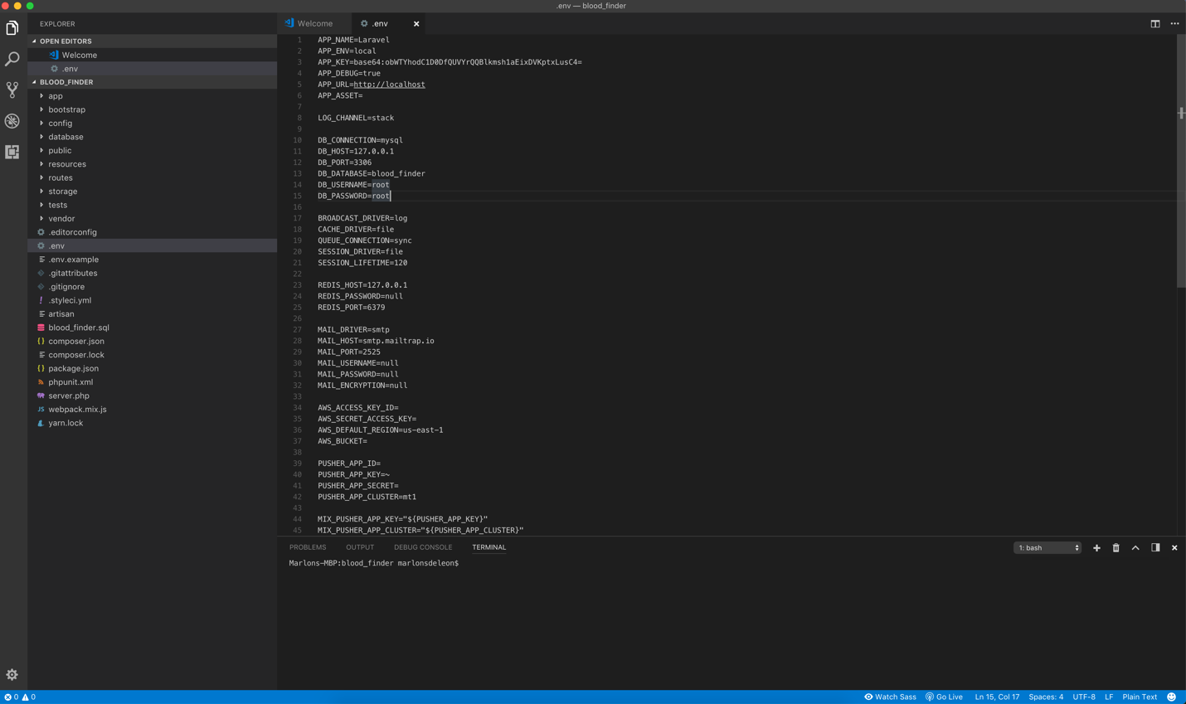Edit “.env” file and change the DB_USERNAME and DB_PASSWORD depending on your phpmyadmin user access. On windows, username = root / password = BLANK
4. Test the “web app” in your browser 🡪 url: localhost:XXXX/blood_finder/public/index.php OR localhost/blood_finder/public/index.php
   * Note that port number (in red) is optional depending on your XAMPP configuration.
5. Update “MainActivity.java” and change the WBview.loadUrl(“ . . . . . . . . . . “) IP address value based on the IP of your local machine then build/run the application.
   * Use STATIC IP and not localhost
   * 192.168.1.X:XXXX/blood_finder/public/index.php OR 192.168.1.X/blood_finder/public/index.php

